**Deployment Of Java Project Using Apache Tomcat**

**First Approach**

1. First You have to go project which is WebsiteEnquiry.
2. Open the WebEnquiry folder.
3. Then go module.
4. Then go to target folder.
5. Copy the WebEnquiry-Web.war file.
6. Open the tomcat folder and then webapps folder .
7. Paste the WebEnquiry-Web to WebEnquiry-Web.war file inside the webapps folder of Tomcat.
8. Then to bin folder of Tomcat and start the tomcat server.
9. Go to any bowser and open the tomcat (i.e.localhost:portno) .
10. Go to manager apps.
11. Open the to /WebEnquiry-Web and Enquiry Form will be show.

**Second Approach**

1. **Go to Tomcat folder where Apache Tomcat installed.**
2. **Go to bin folder.**

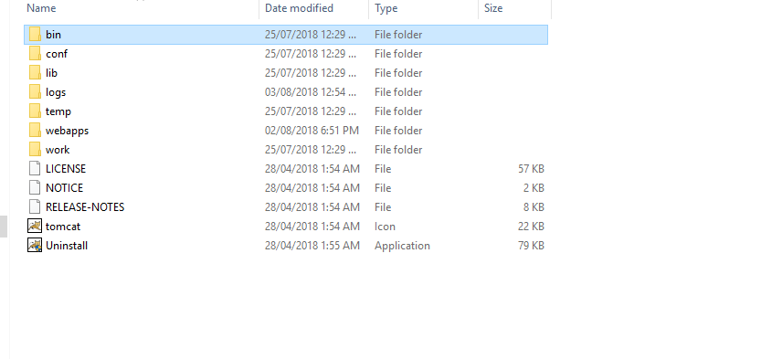

1. **start the tomcat application.**

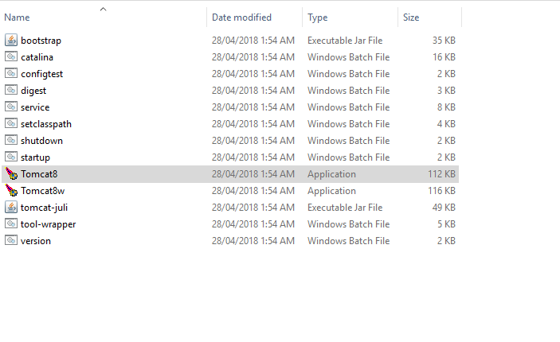

1. **Go to any bowser and open the tomcat (i.e.localhost:portno) and go to manager apps.**

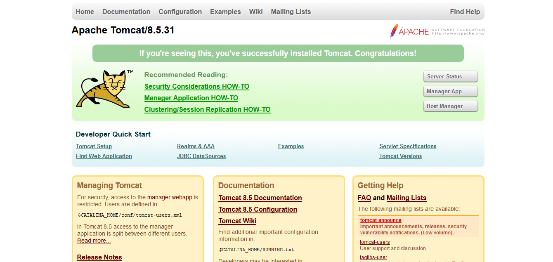

1. **After open manager apps deploy the WAR file from project.**

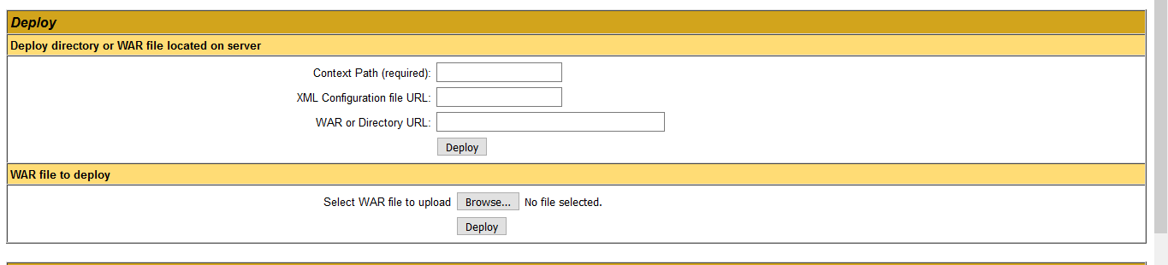

1. **Click on the deployed WAR.**

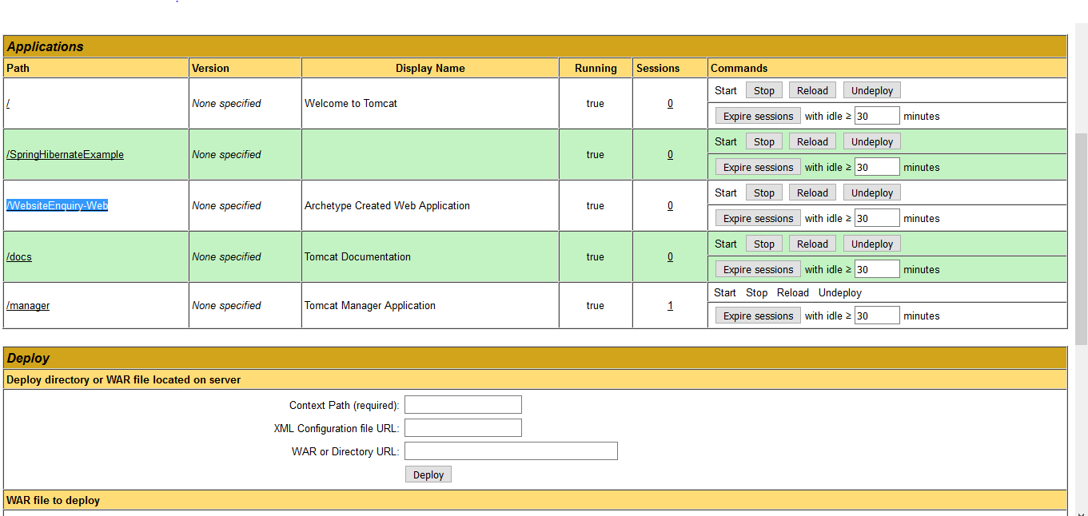

1. **Then Enquiry Page will be open and look like this.**

